**Requirements Specification**

Group A

|  |  |
| --- | --- |
| Chaman Ali | 15016005 |
| Chenlei Jie | 01318877 |
| Keith Feeney | 15015556 |
| Surendra Dura | 15007669 |

**Overview**

*This document is submitted in partial fulfillment of the Business Application Development module 2017 delivered by Manuel Tova-Izquierdo.*

Table of Contents

Product Overview 3

Use Case Design 3

GUI 3

Technical Specification 3

Gantt Chart 3

Deployment Strategy 3

# Product Overview

The group is developing a product specifically for OAPs while specialising in those living alone

The aim of the website is to assist in eliciting information, which is provided from a variety of different services in this domain. This will assist in providing the best service and information, based on the customer’s personal needs.

The product itself would not have any new information, as the information would be retrieved from the services and also be available on the service’s own website. The product’s purpose is to bring all these services to one place.

The main users of the product would be the Customer and Company. Admins would also have access.

Customers and Companies can create an account, login, or edit their details from the product. Admins would be able to delete accounts but creating an admin account or logging in would be outside the system.

Companies can add information, services or events, but these must be approved by an Admin before being public. Customers can search information, services, or events (also book events) and save them to a personal area on the website.

Comments can be added by both Customers and Companies, but they must be approved by an admin. Payment for maintaining the site would come from the Company where a small fee would be added to publish information (etc.) to the website. **[10% of Marks]**

# 

# Use Case Design

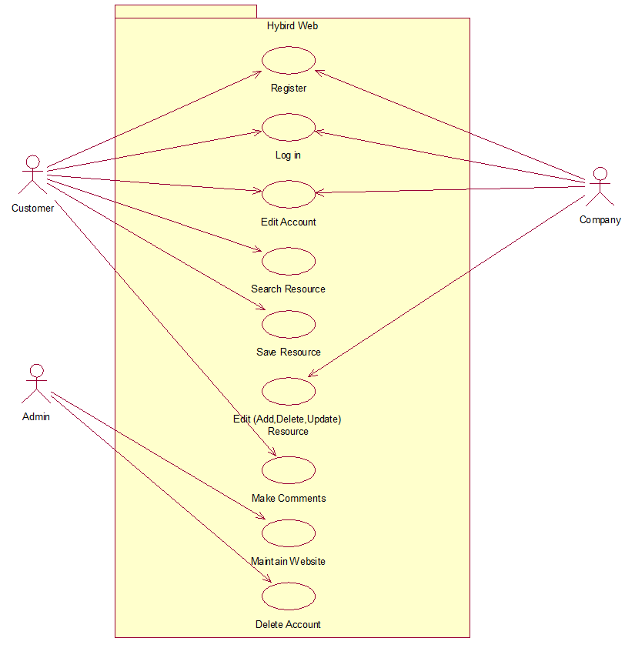

## Use Case Description

### Use Case One

Customer Search Resources

**Scope:**

The scope of this use case is for customers search any resources relative to their needs including services and events.

**Description:**

This use case describes the process that how customers search for the resources that they required.

**Flow Description**

***Precondition:***

The system is idle and available.

***Activation:***

The use case starts when customers type in the search box or browsing the website.

***Main flow:***

1. Customers start to search the resource. [A1: From Navbar] [A2: From Search box]
2. List of links which relative to the search topic will showing on the pages, and customers can click the link to get more information.
3. The key words that customers used to search and also the links which are opened will be stored in the history after customer’s log in.
4. The searching resource can be saved by customers to their Favourite.

***Alternate flow:***

(A1: From Navbar)

1. Different categories of services or events will be listed under the Navbar.
2. Customers choose the resources they required.
3. Continue in main flow point 2.

(A2: From Search box)

1. The link pages will not be showing up when customers type the wrong words.
2. The link pages will not be showing up when there are no relative resources.
3. Continue in main flow point 2.

***Exceptional flow:***

The links will not jump to the information pages when the website is being maintained by Admin or when there are too many users browse the website.

***Termination:***

Customer stop searching resources.

***Post condition:***

The system goes to a wait state

### Use Case Two

Company Edit Resources

**Scope:**

The scope of this use case is for companies edit the information of the resources.

**Description:**

This use case describes the process that companies add, delete or update the information of the resources

**Flow Description**

***Precondition:***

The system is idle and available.

***Activation:***

The use case starts when companies edit resources in the manageable page.

***Main flow:***

1. Companies log in to the website (a1 Register).
2. Go to the manageable page and start edit the information of resource.
3. Save the changes for updating.

***Alternate flow:***

(A1 Register)

1. Companies who haven’t log in to the website cannot edit the information of resources.
2. Continue in main flow point 2.

***Exceptional flow:***

The editing will not be process when the web pages are being maintain. And also the changes will not be showed up if the admin not provide the access of the information.

***Termination:***

Companies stop editing the information and save all the changes.

***Post condition:***

The system goes to a wait state

These Use Cases were chosen as these are the most important.

# GUI

Each group must include mock-ups of the key pages or stages of the system. Explain how they are linked. Explain how you addressed requirements in the design. It is important that the mock-ups are in line with the functional requirements, e.g. one requirement is “user registration” then one of the screens listed in this section should show a registration page.

# Technical Specification

Our project website would include a wide range of technologies to work and run properly, so we are using Bootstrap, HTML, CSS, JavaScript, PHP and MySQL.

## Bootstrap (HTML, CSS)

Bootstrap is affective front-end framework which could be used with HTML5 and CSS to build responsive websites or applications. We will use Bootstrap so that our application could work easily on all phones, tablets and desktops. Bootstrap is very good when it comes to mobile useable websites. Bootstrap has no limitation over the use of browser so there would be no problem when we run our website on any browser whether it is on mobile, tablet or desktop.

We would use Bootstrap forms for the companies and users who could easily register themselves and find the right choice for them to get the services. Bootstrap will work as our front-end or User—end view.

## PHP

PHP is Server-side scripting language. We would use PHP to create, update or delete or closing the files on the server side. We will use it one back-end. We would create dynamic content to put on the Bootstrap created pages. We will use PHP scripts to control the user’s access to the website. We will use PHP as security of the website as well. We will integrate PHP with MySQL which will our database to store data on the server so we could use PHP to restore, delete or even update data from the server. PHP is able to contain text, HTML, CSS, JavaScript and PHP code.

## MySQL

We will mainly use MySQL to get data from the user through Bootstrap forms as registration page. We would save this incoming information in MySQL over a server and when the user will try to log in then this MySQL database will match that info with info present on the database then it will let the user to get into website with the access to connect with companies and charities present on the website. We would be able to update, delete and create data whenever needed. Companies and charities data would be saved on our server in MySQL.

Bootstrap, PHP and MySQL including HTML, CSS and JavaScript will be integrated with each other to make a website which would be working fully at any browser and any device with full capabilities.

# Gantt Chart

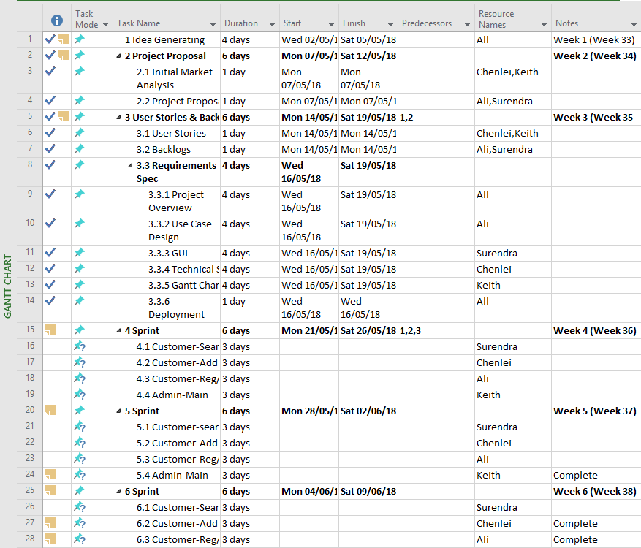

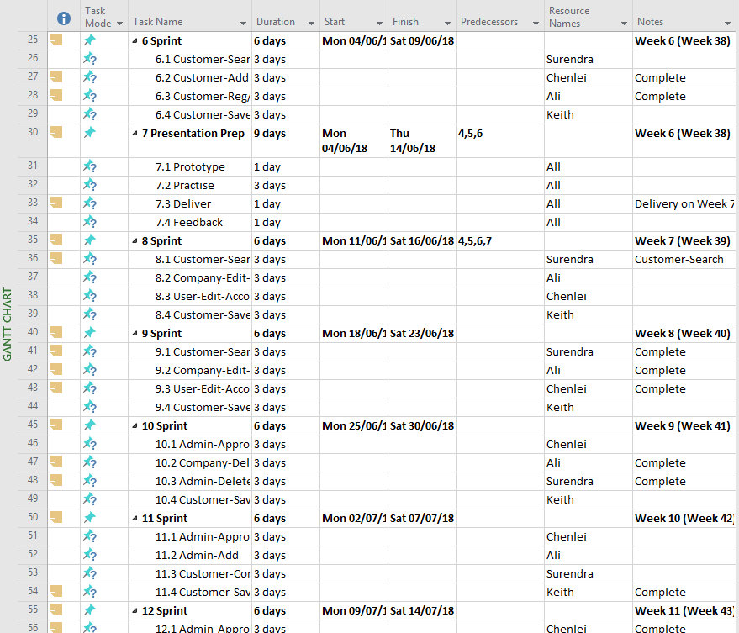

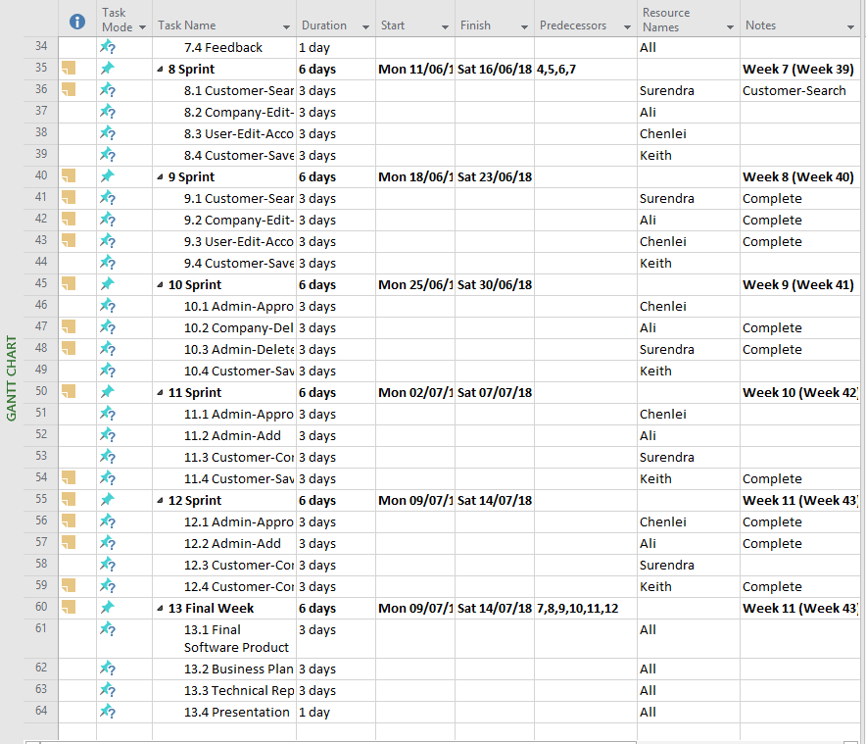

# Deployment Strategy

The product will be released in beta on 17 July, 2018, where a small number of Companies and Customers will be able to join before release.

After 1 month, the initial release will occur.

The product will allow Companies to add information, services and events for free for the first month after initial release.

An advertising campaign will occur to no more than €10,000 on radio and television during this time to allow users to gain knowledge about the product.